Caller/User: <http://localhost:5000/caller.html?target=911>

Receiver/PSAP: <http://localhost:5000/psap.html?login=911&auto=true>

1. Caller has dialled 911 and PSAP user has not accepted the call yet, caller entered some message in chat message area and PSAP user able to see that message without accepting the call is this expected? Please confirm. Also, I see following exceptions in the console (at PSAP user side). – This issue still exists. Instead of this exception, can we display an alert message stating “call is already ended you cannot send any text message to PSAP”.

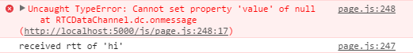

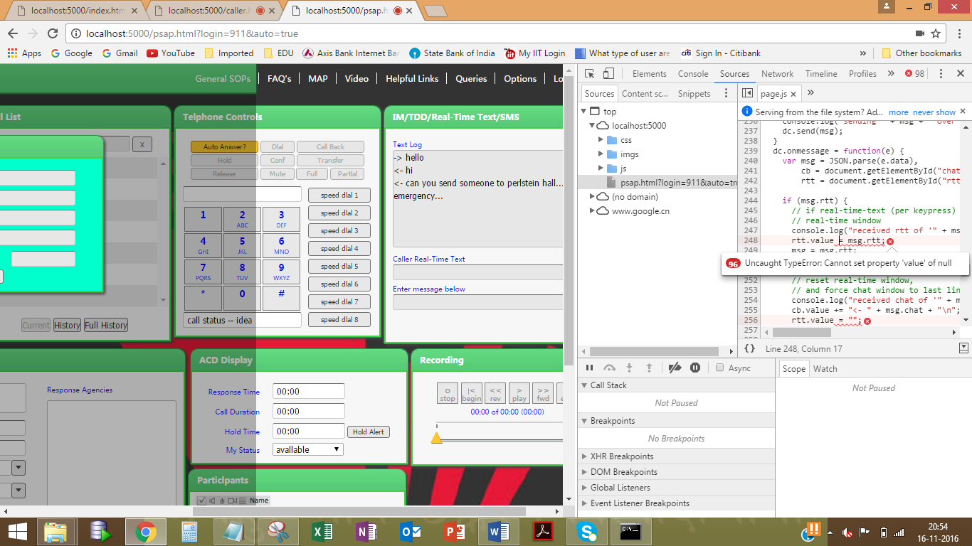

1. Camera option is still enabled from PSAP side even after closing the video dialog box and it is also visible in user call page.
2. Call is declined from PSAP end but still the user can send messages to PSAP. I see same exception messages in PSAP console as shown in defect 1. The “Decline” button which is displayed while receiving the call should function as “Release” button (under Telephone Controls).
3. Getting “Uncaught DOMException” after performing below sequence:

* User makes a call to PSAP.
* PSAP accepts it and Releases the call.
* User sends a text message to PSAP

Actual: Getting Uncaught DOMException.

Expected: Should display an alert message as described in defect 3.

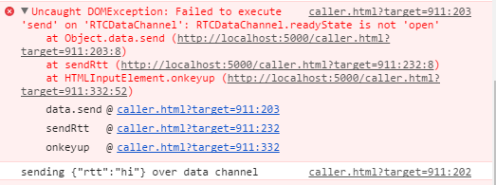

1. When the PSAP user selects Decline or Release, the call should be terminated from both the ends immediately. As of now the call is getting terminated only on PSAP side. But if I click on End button on User side, call is getting terminated on both the ends.
2. User calls PSAP and immediately End the call, but in the PSAP UI, I still see Incoming Call dialog active. This is incorrect, once the call is terminated from User side, the Incoming Call dialog should be closed.
3. When we disconnect the call from either PSAP or USER side, I don’t see any communication between the PSAP and USER, I don’t see any messages in the console nor in the windows command prompt.
4. Whenever I refresh the PSAP page, I see below error message.

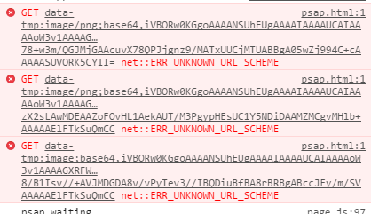

1. What is the use of this this text box?

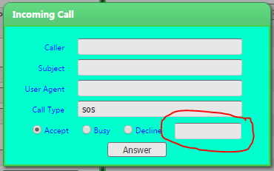

I gave some text as a reason for Busy/Decline actions, but I did not see that in the JS message nor in the console.